OPEN SYSTEM INTERCONNECTION (OSI) LAYER

OSI Layer :

The Open Systems Interconnection (OSI) model is a conceptual framework that standardizes how different computer systems communicate over a network by dividing the process into seven distinct, manageable layers.

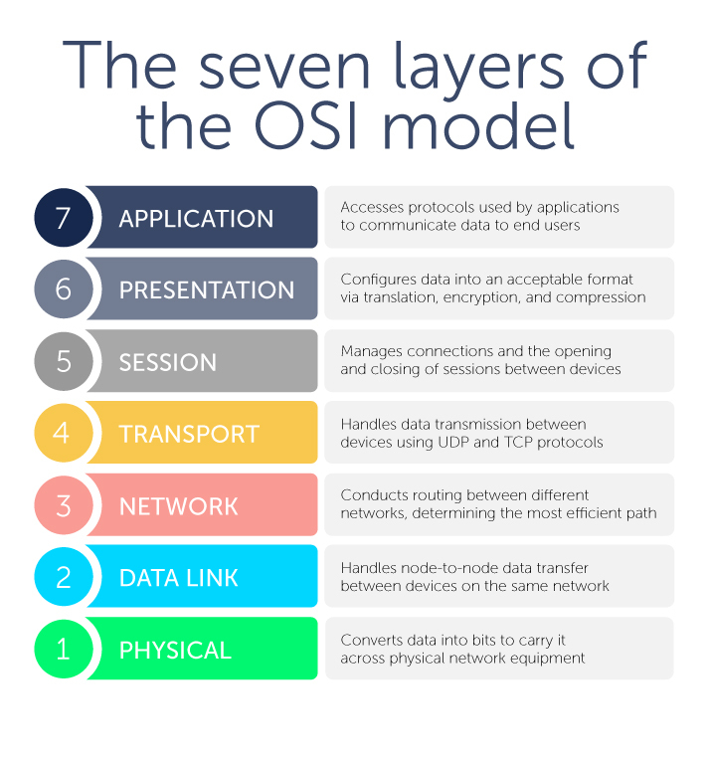

The seven layers of the OSI model :

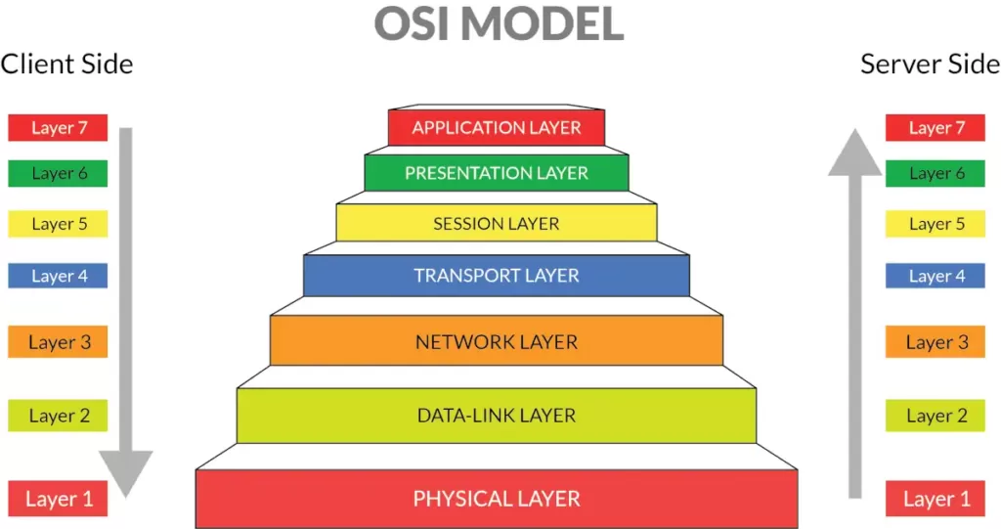

Layer 7: Application Layer

* This is the layer that the end-user interacts with directly. It provides network services to user applications.
* Functions: Interacts with software applications, identifies communication partners, and determines available network resources.
* Protocols and examples: HTTP (for web browsing), FTP (for file transfers), DNS (for domain name resolution), and SMTP (for email)

Layer 6: Presentation Layer

* This layer is responsible for translating, encrypting, and compressing data.
* Functions: Ensures that data is presented in a format that the receiving application can understand. This includes character-set conversions and data encryption/decryption.
* Protocols and examples: JPEG, GIF, and TIFF for image formats; and TLS/SSL for encryption.

Layer 5: Session Layer

* The session layer establishes, manages, and terminates connections between applications.
* Functions: Handles authentication and authorization. It can also manage "checkpoints" in data streams to ensure that if a connection fails, data transfer can resume from the last checkpoint.
* Protocols and examples: RPC and PPTP

Layer 4: Transport Layer

* This layer is responsible for end-to-end communication between devices and ensures reliable data transfer.
* Functions: Segments data from the upper layers and reassembles it at the receiving end. It can also manage flow control and error checking.
* Protocols and examples:

1. TCP (Transmission Control Protocol): A connection-oriented protocol that ensures all data is delivered reliably and in order. Used for web browsing and email.
2. UDP (User Datagram Protocol): A connectionless protocol that is faster but less reliable, suitable for real-time applications like video streaming and online gaming.

Layer 3: Network Layer

* The network layer is responsible for addressing and routing data packets across different networks.
* Functions: Determines the best path for data to travel from the source to the destination.
* Protocols and examples: The Internet Protocol (IP).

Layer 2: Data Link Layer

* This layer manages node-to-node data transfer and handles framing.
* Functions: Divides data packets into frames and adds a physical address (MAC address). It also detects and corrects errors that occur at the physical layer.
* Protocols and examples: Ethernet and Wi-Fi

Layer 1: Physical Layer

* The lowest layer of the model, this is where the physical connection between devices is defined.
* Functions: Transmits raw bits over a physical medium, such as a copper cable, fiber-optic cable, or radio waves. It defines the electrical and mechanical specifications of the connection.
* Protocols and examples: Specific cables, network interface cards (NICs), and connectors.

